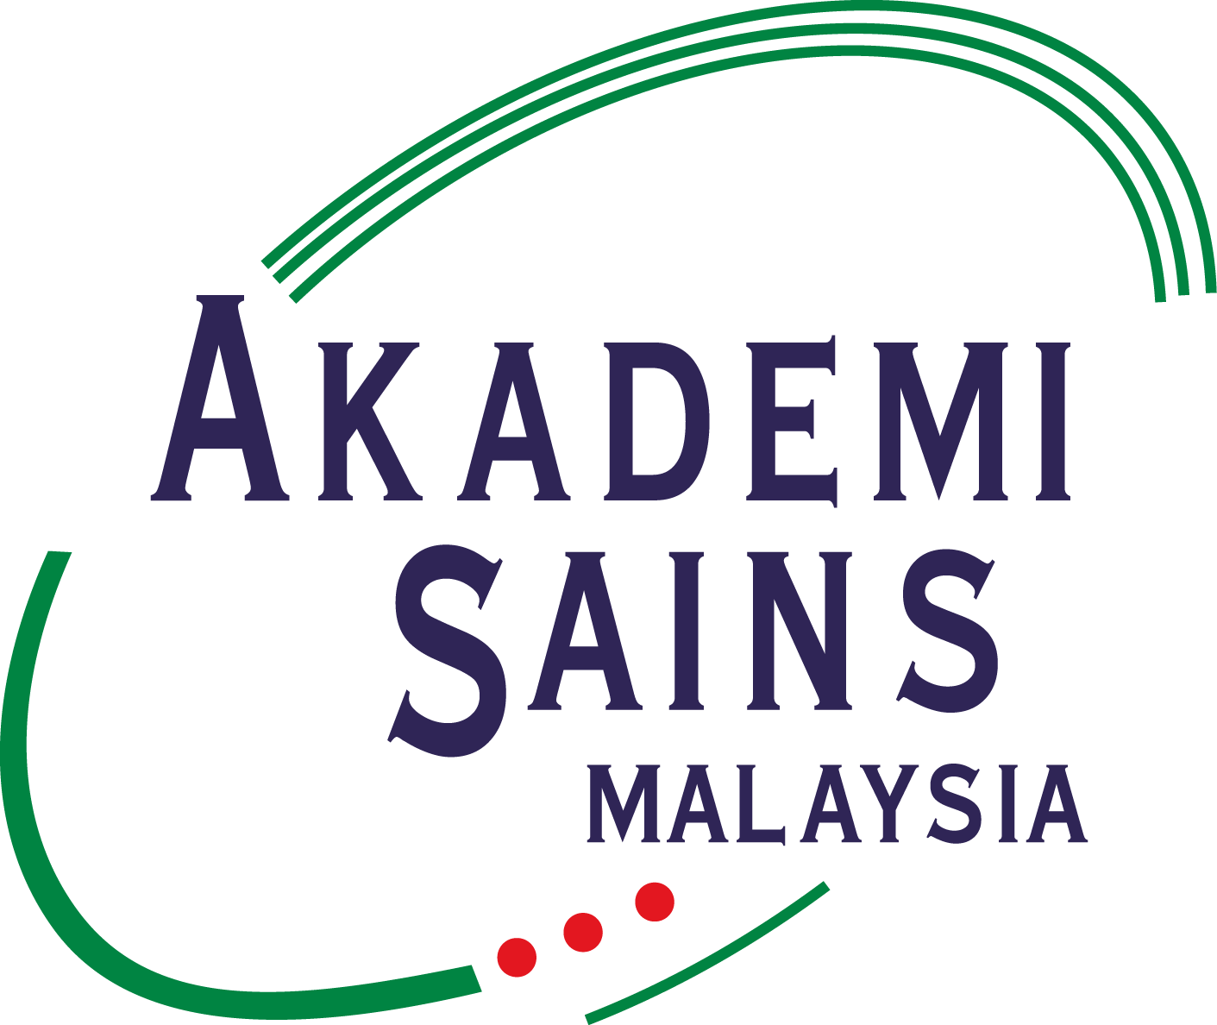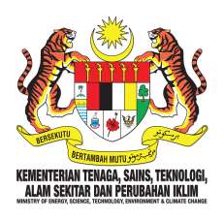
Dr Ranjeet Bhagwan Singh
2018 Medical Research Trust Fund Programmes

RBS Medical Research Grant

Dr Ranjeet Bhagwan Singh (RBS) Research Grant is an annual programme under the RBS Medical Research Trust Fund to be awarded to one (1) young Malaysian scientist to undertake medical/ biomedical research.

1. Eligibility Criteria
Applicant must be a research scientist/ physician with the following criteria:
- Malaysian citizen currently residing in Malaysia;
- The applicant must not exceed 40 years of age at time of application;
- The applicant has to possess at least a basic University degree; and
- He or she must be currently working in a public or private Institutions of Higher Learning (IHLs), or a Research Institute (RIs) in Malaysia, by proof of an employment contract attached with their application.

2. Selection Criteria
- Fulfilled all required items in the proposal (including a detailed budget breakdown);
- Scientific and technical merit: Project should focus on Medical/ Biomedical research and must be scientifically sound;
- Research competence: Project should be completed within 24 months;
- Innovativeness of the project;
- Potential contribution to nation and society;
- Funding appropriateness; and
- Top Research Scientists Malaysia (TRSM) Score.

3. Scope of Grant
- Maximum amount is RM30,000.00 per award.
- The project must be carried out in Malaysia and completed within 24 months (2 years).
- The awarded grant should be used for research materials only.
- The awarded grant cannot be used for travel, wages or allowance for temporary and contract personnel and to purchase any equipment; including personal computer, laptop, printer, server and scanner.
- The grant will be disbursed through the candidate’s institution by MESTECC.
4. Output
The recipient of the research grant should deliver the following:
- A progress report every 6 months that includes achievements and updates up till the milestone reached;
- Submit a final report, including detailed financial statements to the Academy of Sciences Malaysia (ASM) upon completion of the project, within 3 months after the completion date.
- Produce at least one (1) publication in the ASM Science Journal or another peer-reviewed science journal within 6 months after completion of the project.

5. Intellectual Property
Research findings should be jointly and equally owned by the researcher, institution, ASM and MESTECC.

6. Application Procedure
All applications must be submitted online through the Top Research Scientists Malaysia (TRSM) database at www.mytopscientists.org.

